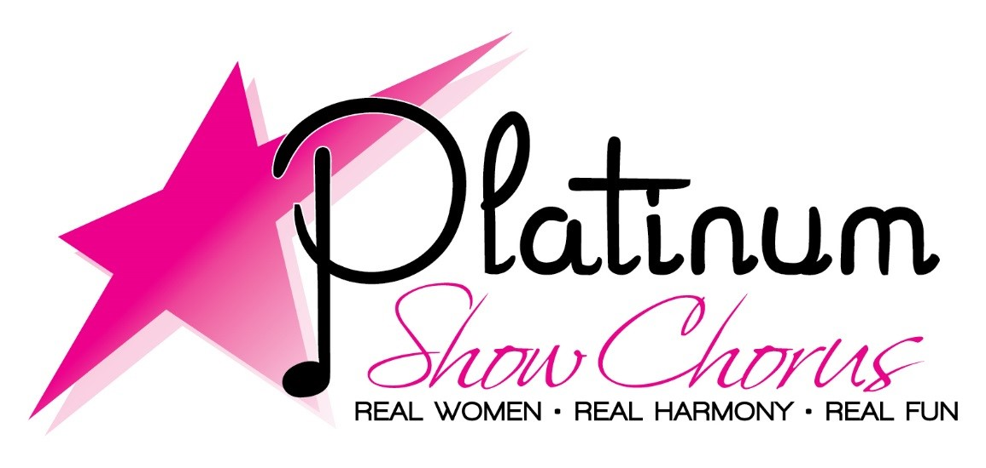

We KNOW you can sing!

Join us at our Guest Nights for

FREE VOICE LESSONS

Thursdays 7:00 – 9:00 PM

February 15, 22 & March 1, 2018

Unity of Melbourne

2401 N Harbor City Blvd

Melbourne, FL 32935

For more details, contact Michele

garneau37@gmail.com

1-877-255-6365

Platinum Show Chorus, a chapter of Sweet Adelines International, is a 501(c)3.

Have fun and learn to sing a cappella with the Platinum Show Chorus

www.platinumshowchorus.com

Want to be *Pitch Perfect*?